JEREMIAH NYAGAH NATIONAL POLYTECHNIC

ELECTRICAL AND ELECTRONICS DEPARTMENT

AUTOMATE AN ELECTRICAL MACHINE

ASSESSMENT III

70 MARKS

Qualification Code: 071306T4EEN
Qualification: Electrical Engineering Level 6
Unit Code: ENG/OS/PO/CR/05/6
Unit of Competency: Automate an electrical machine

INSTRUCTIONS
- Attempt ALL questions in Section A and B
- Marks for each question are indicated.

SECTION A (35 MARKS)
- What are the key factors to consider in designing an automation system? (3 Marks)
- Describe the function of sensors and actuators in an automated system. (4 Marks)
- Explain how PLCs are configured during implementation. (3 Marks)
- What is the purpose of logic gates in automation design? (2 Marks)
- Differentiate between ladder logic and structured text as PLC programming languages. (4 Marks)
- What steps are involved in testing the parameters of an automation system? (3 Marks)
- Define and give examples of system efficiency testing methods. (3 Marks)
- Outline the procedure for simulating a system before implementation. (3 Marks)
- What are the risks of skipping a proper simulation phase in automation? (2 Marks)
- Name three test values to be obtained and how they should be accurately recorded. (3 Marks)
- Describe how to interpret a failed automation system test and correct it. (3 Marks)
- List three safety procedures to follow when conducting system testing. (3 Marks)
SECTION B (30 MARKS)
- A factory plans to automate its packaging unit using a plc packaging system as shown in fig 1, such that:
- Start and stop PB is used to start and stop the whole process
- Photosensor is used to detect product.
- Once the count reaching 10, the robot arm takes responsible for packing.
- Packing complete sensor turns on to restart the process
- Stop PB is pressed any time to stop all processes.

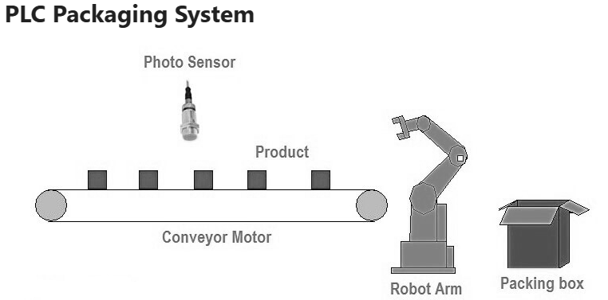
a) Program FBD sequence to control packaging. (7 Marks)
b) Outline and conduct testing and debugging of the system. (8 Marks)
- You are assigned to maintain a malfunctioning assembly line.
a) Explain three diagnostic tools or methods for detecting faults. (6 Marks)
b) What calibration procedures should be followed after servicing? (6 Marks)
c) Design a simulation model and explain how it confirms correct operation. (8 Marks)

